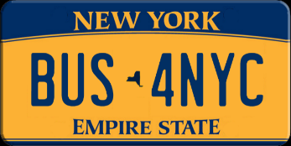
Statement In Response to the TMRB regarding private buses under the
Central Business District Tolling Program.

BUS4NYC Coalition Inc. would like to point out the following in support of bus exemption.

- There are vital commuter bus companies serving the NY riding public CBD that are NOT under government contract, but provide daily commuter service, including participation in the National Transit Database that generates funding for New York State and MTA.

- Private and government owned buses serve the same riding public passengers.

- Buses mitigate congestion - they are part of the solution, not the problem. Privately owned buses represent LESS than 1% of vehicles projected to be in the CBD at peak periods.

- Public or privately-owned, each bus potentially removes 55 cars from the CBD. One bus footprint occupies less space than 55 cars, 55 bicycles, or even 55 pedestrians.

- Congestion programs in London, Stockholm, Singapore and other cities should serve as a guide. They exempt High Occupancy Vehicles (HOVs). New York City Traffic Rules have set passenger guidelines for definitions of a bus.

- Requirements of the F.A.S.T. Act require toll parity between privately-owned and public buses in recognition that they serve the same riding public.

- NYC acknowledges the benefit of all buses to the public through the successful implementation of exclusive BUSWAYS (such as 14th Street), BUS LANES and HOV lanes. These benefit the RIDING PUBLIC on ALL BUSES.

- Bus types include Commuter, Inter-City, Tour/Travel, Airport, Convention Shuttles and Special Operations. Buses also provide private and government emergency response for Military, Medical, Special Events and Weather-related shutdowns of Airports, Railroads, Schools and other public needs.

- Congestion in the CBD is exacerbated by private autos and excessive truck deliveries to residents and workers ordering online. Automobile traffic has also increased due to perceived safety issues on the subways and transit system. Buses are not the problem.

Glenn Every President, Patrick Condren Administrator BUS4NYC Coalition Inc. www.bus4nyc.org 917 836 3685

